The Original Language

Author: Quang Huynh

It was the beginning. There was no language, no words, no alphabet, no way to **verbally** communicate with family and friends, but there was one way. Well, you’re probably asking, how did they communicate with others without using words, without speaking, none of that? Well, simple, they had used art, such as paintings, and drawings to communicate. But then, what materials did they use back then to create art?

The First Cave Art Discovered and The First Artists

It was *1896*, and you had discovered a cave in *Spain*, in the city of *Santander*, and you just to explore the cave. As you adventure more and more, you begin to see these animals splattered across of the walls of the caves. Then you wonder, how did they get here? As you look at some of the animals, you notice a bison. What you found was the first cave ever discovered, not the oldest cave discovered, but the first cave discovered. But according to the article, *“The Origins of Cave Paintings,”* it said *“…when cave men were alive, only a few very special people were allowed to paint.”* Those people who had permission to paint were called **Shaman**, also called hunter-magicians. Also, another phase from the article, *“The Origins of Cave Paintings,”* says that, *“…why do you think there are so many different animals? [in this cave] They were painted at different times. Each group of animals likely represents a hunt that was performed at a different time. It would seem as though they used this cave over and over again for artwork, with many different artists taking turns.”* The cave that was discovered in this paragraph was named the *“Bison of the Altamira Cave”* because of the frequent bison seen in the cave. The cave dated back *14,000 B.C.* But also remember, this cave was the first cave discovered, and think how much surprised the scientists at the time were, now then, imagine how you would feel if you discovered the first cave art in your time?

The Origins of Cave Art

The origin of Cave Art is to communicate with others, but also has another purpose back then too. That purpose was about culture and religions, and also, an article to the name of *“The Origins of Cave Paintings,”* said that, *“Early cave men believed that if they drew an animal on a wall, they would capture its spirit and the Shaman would be able to control the success of the hunt.”* Since the *Bison of the Altamira Cave contained mostly of bison, who do you think they were trying to control? Well, the correct answer is the bison, because the Shaman wanted to control the bison. Next in the list, since early cave men artists had only a* ***limited****, and few materials to work with and paint, they had to work with* what they had found in the wilderness, such as parts of trees, or from the ground, parts of nature or structures. So instead, they had used twigs and leaves as brushes, like paint brushes we use today. Also, they had used cave walls as canvas or drawing paper, and used different types of fruit and dirt for color and paint. So that was basically the origins of Cave Art. Also, that was how the early humans created art back then in 14,000 B.C, with the context of limited materials, so they had to use natural objects to create art. Also with the context of why the early humans created art, and what they believed in. ☺

Cave Art History

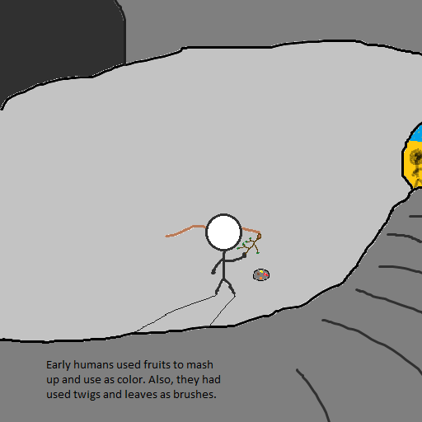So first off, according to an article of the name *“A Journey to the Oldest Cave Paintings in the World”* by *“Jo Marchant,”* it says that Smith had said, *“99.9 percent of rock art is* ***undated****.”* So that means, most caves don’t have real specific times that they were created. Which means some scientists just guess the age or did some research and just estimated how old the cave is. But the oldest cave art known today is at least 35,400 years old. Also, in the same article, it contains the following statement, *“It’s among more than a dozen other dated cave paintings in Sulawesi, that now rival the earliest cave art in Spain and France, long believed to be the oldest on Earth.”* Next, the Chauvet Cave in Southeastern France is around 30,000 to 32,000 years old. Also, since early cave men did not have any words or an alphabet to use to sign their artwork, they instead use their handprints. This is one of the very first signatures that a human would probably use. Also, in an article, it says that, *“Archaeologists in South Africa have found that the pigment ocher was used in the caves 164,000 years ago.” Which meant that humans have been mixing up colors with fruits and dirt just after around when they had invented Stone tools a couple of hundreds of thousands of years ago. That is some of some Cave Art History based on the articles.*

*Glossary:*

***Verbally****: speech or noise by using the mouth*

***Shaman****: Those whose have permission to paint and create art*

***Limited****: short in amount*

***Undated****: not marked with a date*

*Sources:*

*"A Journey to the Oldest Cave Paintings in the World”* by *Jo Marchant; article*

*"The Origins of Cave Paintings"; article*